Exercise Solution

Task - 01
Modify the code so that it adds 3 to AX in each iteration instead of 2. Predict the final value in AX after 5 iterations.

INPUT:
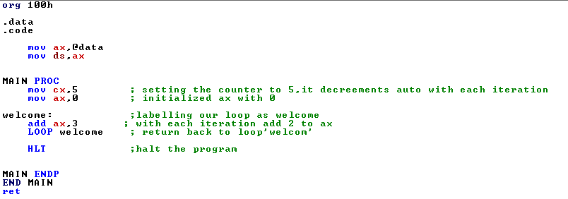

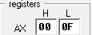
OUTPUT:
- The output is expected to be 15(F).

Task – 02
Change the loop counter to 7 (i.e., MOV CX,7) and observe the final value in AX. Explain how the loop works with different counter values.

INPUT:
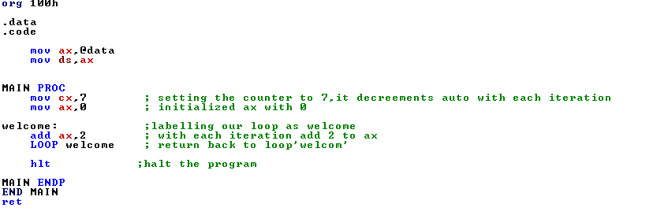
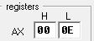
OUTPUT:
- The expected output of the code is 14(E).

EXPLANATION:
This program initializes a 16-bit assembly code that starts by setting up the data segment (`mov ax, @data` and `mov ds, ax`). It then enters a loop labeled `welcome`, where it initializes `ax` to 0 and adds 2 to `ax` on each iteration. The loop runs 7 times, as controlled by the `cx` register (`mov cx, 7`), which decrements automatically with the `LOOP` instruction. When `cx` reaches 0, the loop stops, and the program ends with `hlt`.

Task-03
Replace the ADD AX,2 instruction with SUB AX,1. Run the code and note how AX
changes during the loop.

INPUT:
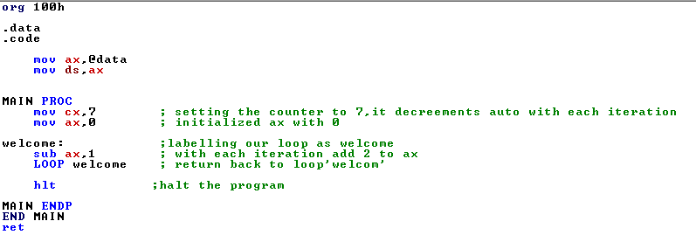
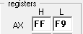
OUTPUT:
- The expected output of the code is -7 (F9)

EXPLANATION:
This program initializes a 16-bit assembly code that starts by setting up the data segment (`mov ax, @data` and `mov ds, ax`). It then enters a loop labeled `welcome`, where it initializes `ax` to 0 and subtracts 1 from `ax` on each iteration. The loop runs 7 times, as controlled by the `cx` register (`mov cx, 7`), which decrements automatically with the `LOOP` instruction. When `cx` reaches 0, the loop stops, and the program ends with `hlt`.

Task-04
Use a nested loop to multiply two numbers by repeatedly adding one to the other.

INPUT:
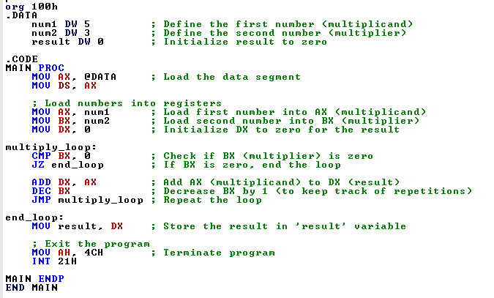

OUTPUT:
By repeated addition of 3 for five times results into fifteen 15(0F).
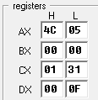

Questions

What role does the CX register play in the loop?

- The CX registers works as a counter in the loop, we can initialize it with number till we want to run the loop, it decrements in each iteration till it reaches zero and then terminates the loop.
How does the LOOP instruction determine when to exit the loop?

How does the LOOP instruction determine when to exit the loop?

- The `LOOP` instruction in x86 assembly automatically decrements the `CX` register by 1 each time it executes and then checks if `CX` has reached zero.
If `CX` is not zero, `LOOP` jumps to the specified label, repeating the loop.
If `CX` is zero, `LOOP` exits and continues with the next instruction after the loop.

What happens if you omit the LOOP instruction and manually decrement CX?

- If we omit the `LOOP` instruction and manually decrement `CX` with `DEC CX`, we would also need to add a conditional jump (like `JNZ`) to continue the loop until `CX` reaches zero. This approach is more flexible since it allows for custom conditions, but it requires extra instructions to check if `CX` is zero. This can be useful when more control over the loop behavior is needed.

